Eda İslam 2585081 | Yağmur Can 2637536
EXPERIMENT IV BASIC APPLICATIONS OF OPERATIONAL AMPLIFIERS
OBJECTIVE:
In this experiment, you will analyze basic circuit configurations with operational amplifiers and resistors. The following concepts will be covered:
1. Controlling the transfer characteristics of circuits using different resistor configurations around a basic operational amplifier (op-amp);
2. Applying node voltage circuit analysis to op-amp circuits,
3. Using feedback techniques to deliver op-amp circuits with predictable performance,
4. Fundamental specifications and limitations of practical operational amplifiers,
5. Use of function generator to deliver, and oscilloscope to monitor AC signals
EQUIPMENT LIST:
DC Power Supply
Function/Arbitrary Waveform Generator
Digital Oscilloscope Op-Amp (μA741)
Resistors (2x100 Ω, 4 x 1kΩ).

PRELIMINARY WORK:

- Open-loop operation (without feedback):

A) The power supply should be connected to the ground and we take the com as the ground node in this circuit. We connect the – side of the power supply to the ground node.

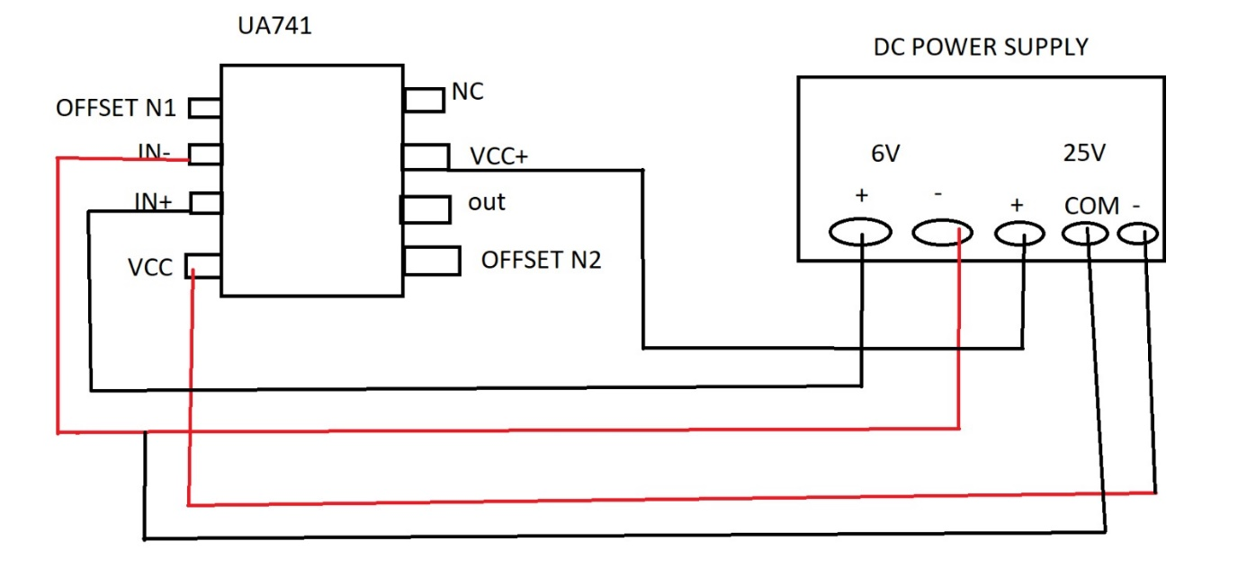
Vin (V) | RL (Ω) | V0 (V) | Input current, i+ (mA) | Is output voltage saturated (Yes/No)? | Is output voltage limited by opamp output current limit (Yes/No)?
0.00001 | 2000 | 1.93 | 5*10^-9 | No | No
0.002 | 3000 | 11.7 | 1*10^-6 | Yes | Yes
0.002 | 200 | 8.72 | 1*10^-6 | Yes | Yes
2 | 200 | 8.72 | 1*10^-3 | Yes | Yes
B)

Rint=2 M Ω=2.000.000 Ω
A=2*10^5
I+ =Vin/Rint

If output voltage is not saturated the formula is: V0=A*Vin*(RL/RL+Rout)
If it is saturated then the formula is: V0=Vcc*(RL/RL+Rout)
C) The formula of the power dissipation is: P= [(V0)^2]/RL
Therefore, in the lab environment we found V0 values by using op-amp and DC power supply and then we use the power dissipation formula to calculate the power dissipated.
D)
Any discrepancies between calculations and simulation stems from calculation errors and cable resistance.
In our data the named variable V(n002) means the Vo.
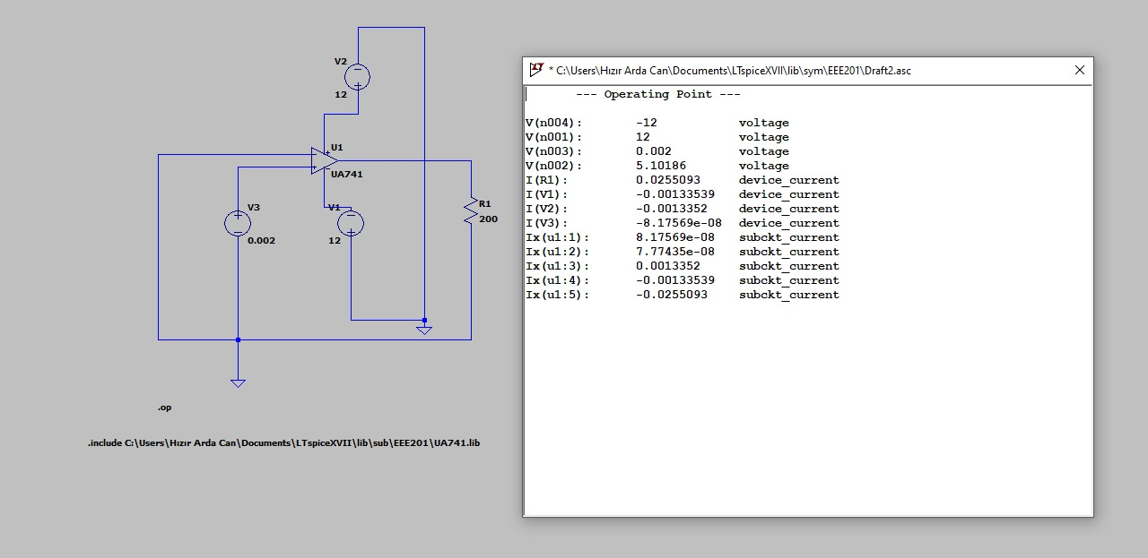

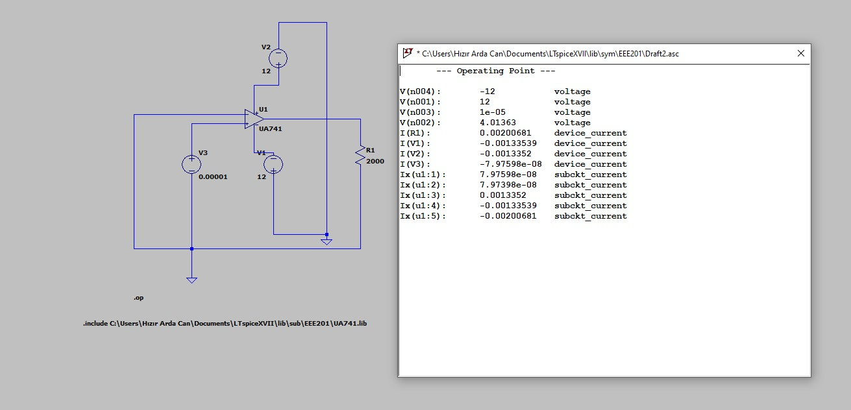

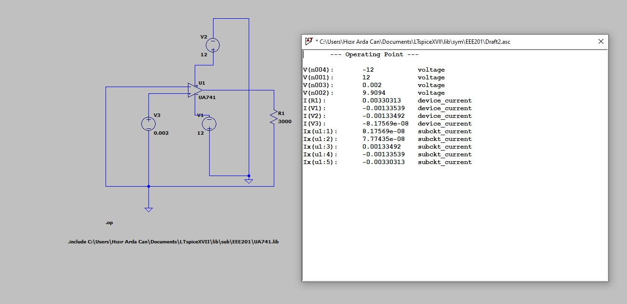

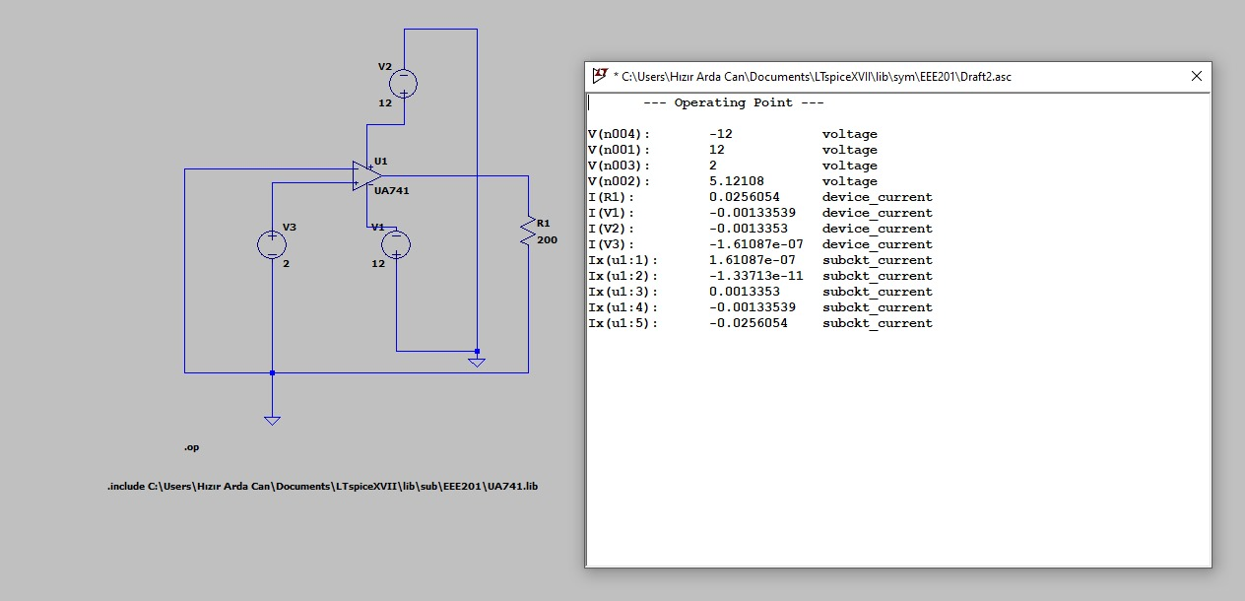

Vin (V) | RL (Ω) | V0 (V) | Input current, i+ (mA) | Is output voltage saturated (Yes/No)? | Is output voltage limited by opamp output current limit (Yes/No)? | Op-amp power dissipation
0.00001 | 2000 | 4.0136 | 7.98*10^-5 | No | No | 8.05*10^-3
0.002 | 3000 | 9.9094 | 8.17*10^-5 | No | Yes | 0.0327
0.002 | 200 | 5.1018 | 8.17*10^-5 | No | No | 0.130
2 | 200 | 5.12108 | 1.61*10^-4 | Yes | Yes | 0.1311

2)
A)
For circuit 1:

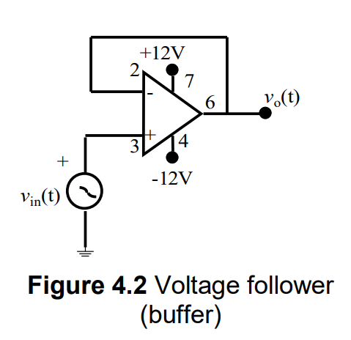
Since there is no resistance in the circuit( R1 and R2 are 0):
Vin(t)=Vo(t) and the gain is A=Vin(t)/Vo(t)=1
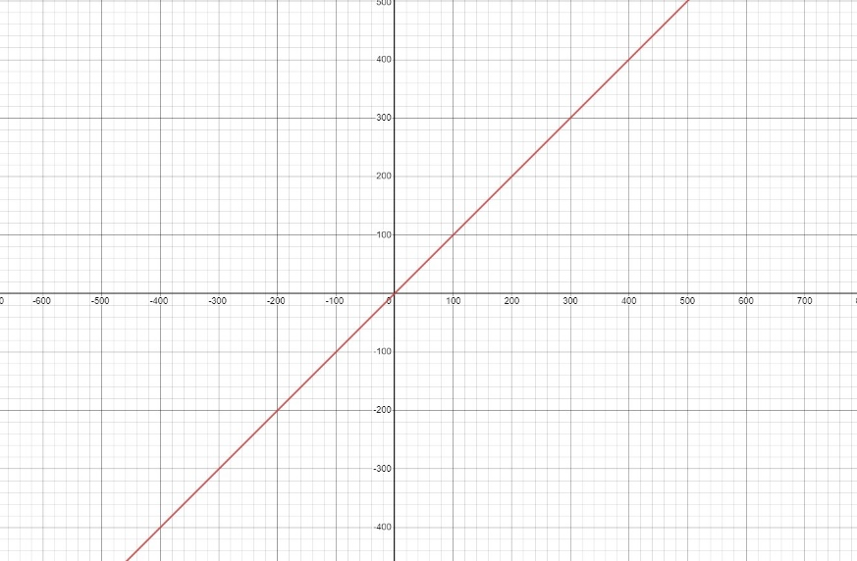

For circuit 2:
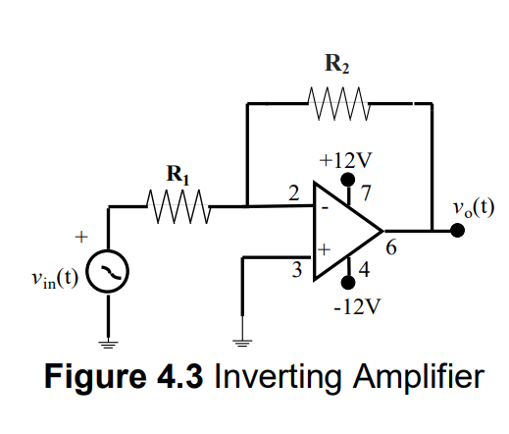
KCL at node 2:
(V-)-(Vin(t))/R1 + (V-)-(Vo(t))/R2 = 0
V-(1/R1 + 1/R2) -Vin(t)/R1 -Vo(t)/R2 = 0
Since the input voltages are the same for the op-amp and negative feedback exists, we can write V- = V+ = 0V
Therefore the calculation becomes to Vo(t)/Vin(t)=-R2/R1 : Inverting Amplifier Gain=-10
The ratio between Vo(t) and Vin(t) is -R2/R1 and with the given values of R1=1.2 kΩ and R2=12 kΩ :
Vo(t)=-10 *Vin(t)
Vo(t)= -10*(3sin1000πt)

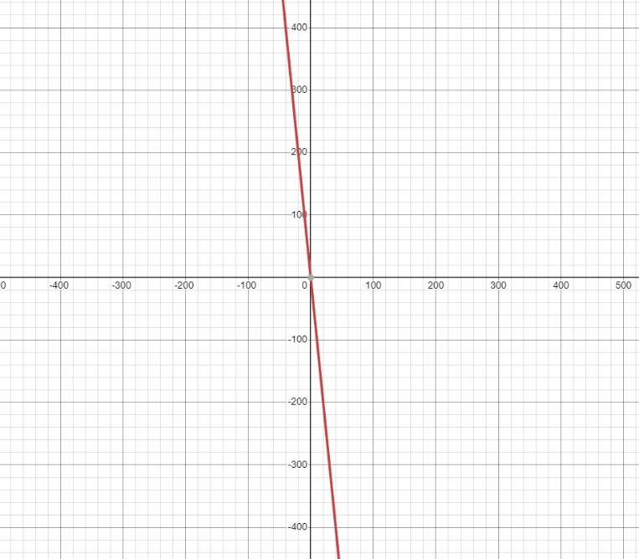
For circuit 3:
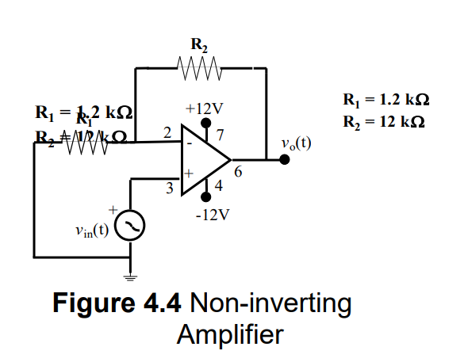
KCL at node 2:
(V-)/R1 + (V-)-Vo(t)/R2=0
The input voltages are same for the op-amp so; V- = V+ = Vin
Therefore the calculation becomes
Vin(t)/R1 + (Vin(t) -Vo(t))/R2 =0
Vo(t)/Vin(t) = (R2/R1)+1 : Noninverting Amplifier Gain =11
The ratio between Vo(t) and Vin(t) is R2/R1 +1 and with the given values of R1=1.2 kΩ and R2=2 kΩ:
Vo(t)=11*Vin(t)
Vo(t)=11*(3sin1000πt)
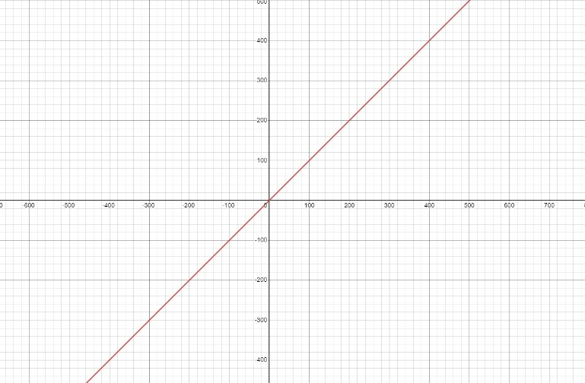

B)

- No the transfer function we derived did not change due to the existence of the negative feedback and ideal op-amp rules.
- The output voltage is 1V since by the KCL and ideal op-amp rules Vin=Vo=1V.
- By the power formula : P=V^2 / R , the power dissipated is P=1^2 / 12 = 8.3*10^-5W
- No, we don’t expect that the power dissipated at RL is equal to the sum of power delivered by Vin. Because in a practical circuit, due to the resistance of the cables and the op-amp, we observe voltage drop. Therefore the power dissipation can’t be same.
- The energy dissipated at the load resistor RL at the end of 1 sec is calculated by the formula Power*Time :
8.3*10^-5W * 1 s = 8.3*10^-5 J

3)
A)
Left side:
KCL at node 2:
((Va)-(V-))/R1 + ((Vb)-(V-))/R2 = ((V-) – Vo)/Rf
Since we assume ideal op-amp model in our calculations V- = V+ = 0
Therefore the calculation becomes Vo= -(Va/R1 + Vb/R2)*Rf
Vo= -[(2sin1000πt)/1000 + (2V)/1000]* 1000
Vo= -[(2sin1000πt)+2V]
Right side:
(Va-0)/R1 + (Vb-0)/R3 +(0-Vo(t))/R2 = 0
Va/R1 +Vb/R3 = Vo(t)/R2
Vo(t) =[ (Va/R1)+(Vb/R3)]*R2
Vo(t) = [ (2sin1000πt/1000)+(2/1000)]*1000
Vo(t)= (2sin1000πt) + 2V

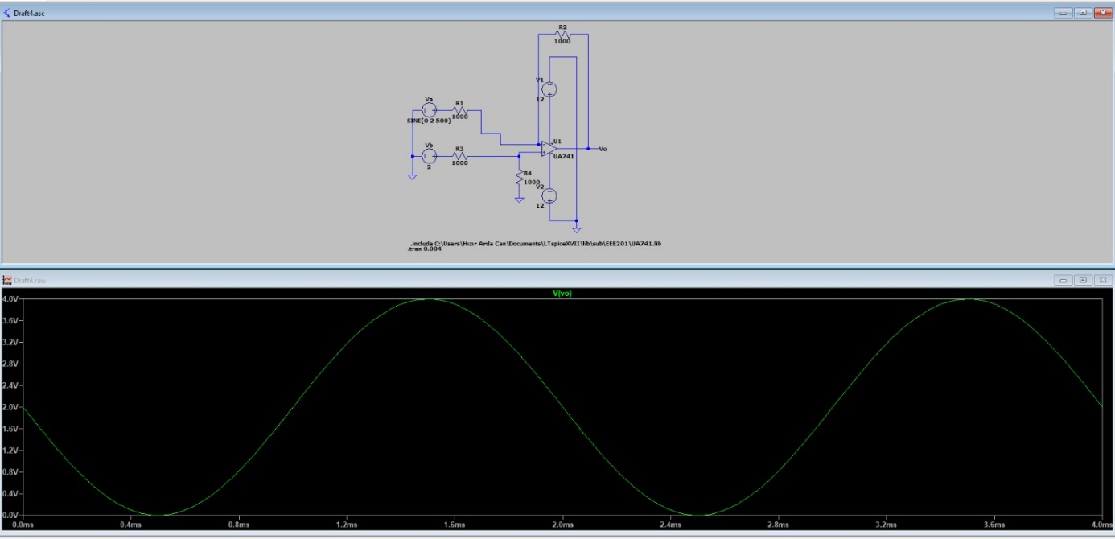
B)
1: LEFT SIDE
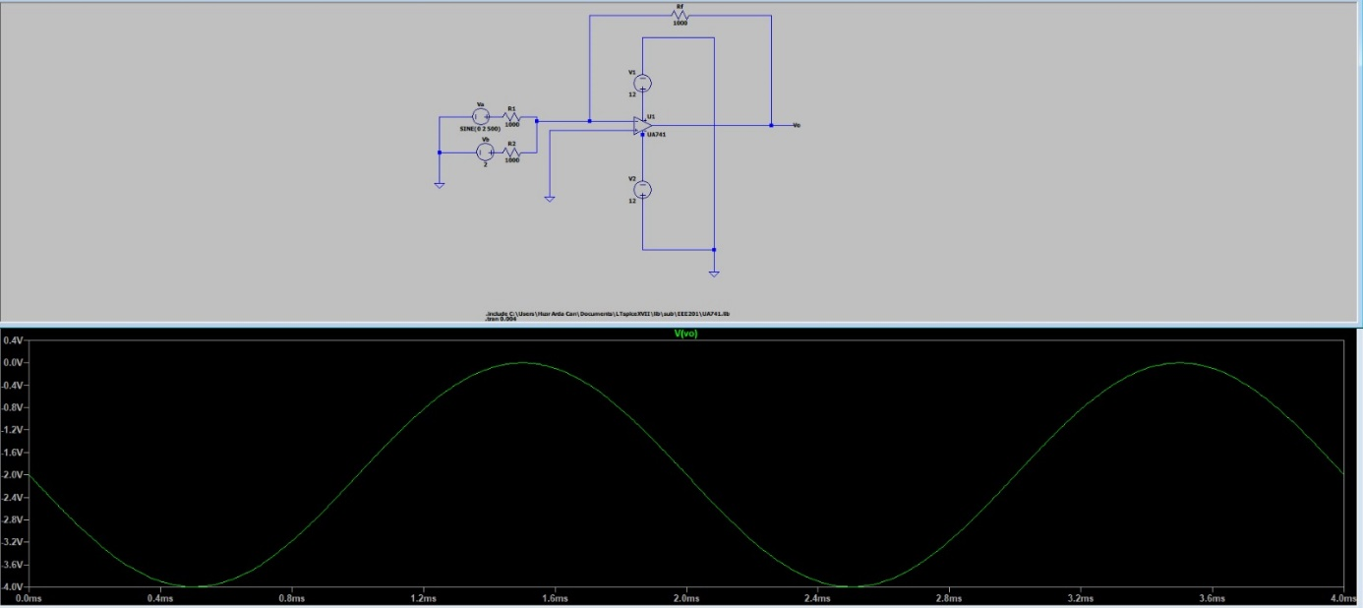
2: RIGHT SIDE

There are a few discrepancies between the calculations and simulations results that is caused by calculation errors and resistance in cables and op-amps. But other than that our results are approximate.
Conclusion:
We learned characteristics of op-amp included circuits by using different resistor configurations.
We learned how to use node voltage technique with op-amp circuits.
We learned some specifications of practical operational amplifiers.
We used function generator as a power supply and we used oscilloscope to visualize the AC waves.
We learned how to include specified libraries to LTspice software.

